**PRIMARY SIX SCIENCE**

**WORKBOO TERM II 2022**

### THEME: THE WORD OF LIVING THINGS TOPIC 1 : CLASSIFICATION OF PLANTS FLOWERING PLANTS.

* Plants are living components of the environment
* A plant is a green growing living thing on the earth’s surface
* Plantsare the primary sources of food to animals

### Classification of plants

Classification of plants means grouping plants according to their different characteristics.

### Plants are classified into two;

1. Flowering plants
2. Non-flowering plants.

**Plants**

**Flowering Plants**

**Non-flowering plants**

Monocotyledon (cereals)

Dicotyledonous Fe (legumes)

Conifers

Maize Wheat

|  |  |  |  |
| --- | --- | --- | --- |
| rns |  |  |  |
|  |
| Mosses | |

Beans Peas Liverworts Algae

### FLOWERING PLANTS

Flowering plants are plants that bear flowers and reproduce by means of seeds.

Flowering plants are made up of two systems

* 1. Shoot system
  2. Root system

Shoot system is the part that develops from the plumule. It grows above the ground.

Shoot system flower

### PARTS OF A FLOWERING PLANT

terminal bud leaf

fruit

root system roots

stem

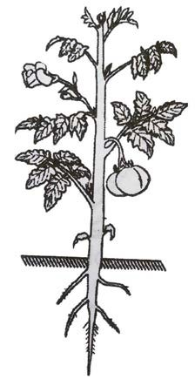

Flowering plants have both root system and shoot system

### Flowering plants are sub-divided into two;-

Monocotyledonous and Dicotyledonous.

### Monocotyledonous plants (cereals):

Monocotyledonous plants are plants that bear seeds with one cotyledon. They are also called **cereals.**

### Examples of monocotyledonous plants:

* Maize
* Millet
* Sorghum
* Rice
* Wheat

### Characteristics of monocotyledonous plants.

* The seeds of monocotyledonous plants have only one cotyledon
* They have a fibrous root system.
* They have a parallel leaf venation
* Their seeds undergo hypogeal germination.

### Dicotyledonous plants

These are plants that bear seeds with two cotyledons.

### Examples of dicotyledonous plants

mangoes, oranges, beans, avocado, peas, ground nuts, soya beans.

### Legumes

These are plants with root nodules on their roots and seeds in pods.

### Examples of leguminous plants:

* Beans
* Ground nuts
* Soya beans
* Peas
* Simsim

### Characteristics of dicotyledonous plants.

* + 1. They have a tap root system.
    2. Their seeds have two cotyledons.
    3. Their seeds undergo epigeal germination
    4. They have network leaf venation.

### Learner’s activity

* + - 1. In **one** sentence state what you understand by the term classification of plants
      2. Name the **two** groups of plants
      3. Apart from root system, mention any other system of a flowering plant
      4. Write **one** way in which roots are useful to;
         1. People :
         2. Plants

Give **two** differences between cereals and dicots.



## **CORRECTION**

### ROOTS:

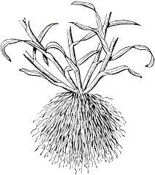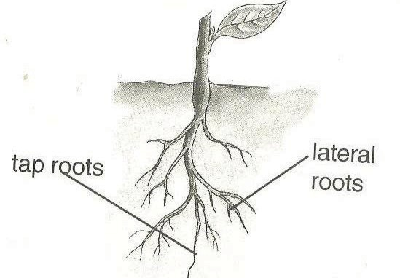

The root system is the part that grows in the soil

The root system involves main root, lateral roots, root hairs and the root cap.

### Types of root systems.

There are basically two types of root systems namely; Tap root system

Fibrous root system

### Tap root system

* Tap root grows directly from the radical of the germinating embryo
* They are commonly found in dicots.

### Fibrous root system

* Fibrous roots grow without a tap root or main root.
* They are commonly found in monocots.

### Draw structures showing parts of a tap root and fibrous root systems

|  |  |
| --- | --- |
| **Tap root system** | **Fibrous system** |
|  |  |

**Function of roots to a plant**

* Roots hold the plant (shoot system) firmly in the soil
* Root hairs absorb water and mineral salts from the soil
* Some plants store their food in swollen roots.
* Prop roots provide extra-support to plants
* Breathing roots absorb oxygen especially in the mangroves.
* Root nodules of legumes store nitrogen-fixing bacteria that improve soil fertility by fixing nitrogen into the soil.

**NB**: Mineral salts enter by a process called active transport.

### Importance of roots to people:

1. Swollen roots with stored food are sources of food to people e.g. Cassava, Sweet po- tatoes, & Carrots.
2. Some plant roots acts as herbs to cure some diseases e.g. Mangoes, Blackjack, Muringa plant, etc.
3. Big dry roots acts as source of wood fuel to people.
4. Some big roots can be used in making craft items.

### Learners Activity

1. How useful is a shoot system to a plant?
2. In the space below, draw the structure of a tap root system
3. Apart from making craft items, state one way in which roots are useful to people
4. In **one** sentence, show the meaning of a flowering plant.
5. Give **two** examples of flowering plants

## **CORRECTION**

### TYPES OF ROOTS

There are basically two types of roots namely:

1. Primary roots
2. Secondary rots

### Primary roots:

* Primaryroots are roots that grow directly from the radical of a seed. Tap roots and fibrous roots are the examples of primary roots

### Secondary rots

* Secondary roots are roots that develop from the other parts of a plant like the stem and leaves.
* They mainly grow to give extra support to the plant with weak stems.

### Examples of secondary roots include;

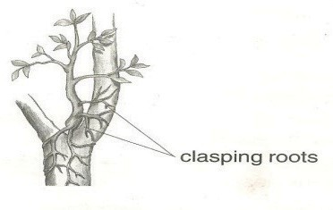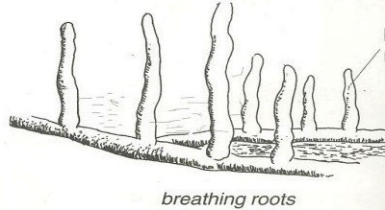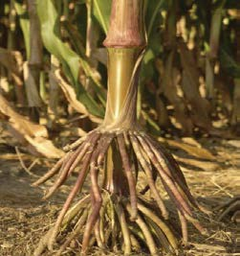

1. Prop roots
2. Aerial roots
3. Breathing roots
4. Roots of rhizomes and corms.
5. Buttress roots
6. Clasping roots
7. Stilt roots

### Prop roots:

Prop roots are common in cereal crops such as, maize, millet, sorghum and wheat.

They mainly grow to provide extra-support to the plant especially at the flowering stage.

### A structure showing the prop root system.

**Note:**

* Cl**a**sping roots enable plants with weak stems climb other plants and trap sunlight energy.
* Stilt roots are found on plants which commonly grow in muddy or swampy areas. They are also known as breathing roots.
* They take in air for respiration of roots. This is because soil with a lot of water does not have enough air

### A structure showing clasping roots & Breathing roots

**Note:** some plants have swollen roots which store food for the plant.

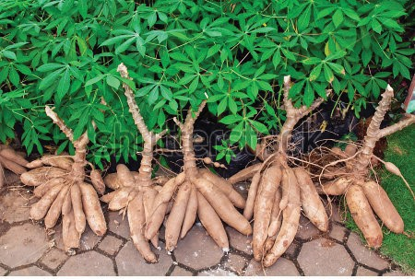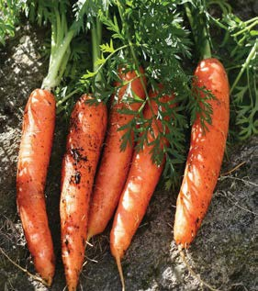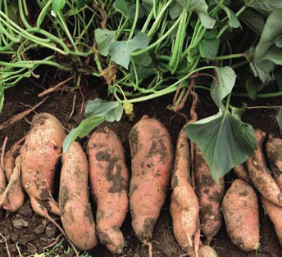

### Root tubers:

These are swollen underground roots that store food for the plant.

### Examples of root tubers:

* Cassava
* beetroot
* Carrots
* radish
* Sweet potatoes
* turnips
* Parsnips

### Structure of root tubers: Food stored by root tubers:

Root tubers store starch. They are good source of carbohydrates.

|  |  |  |
| --- | --- | --- |
| **Cassava** | **carrot** | **Sweet potato** |
|  |  |  |

### Learners Activity:

* 1. In **one** sentence explain the following terms
     1. Primary roots.
     2. Secondary roots
  2. Give **two** examples of secondary roots
  3. State the importance of prop roots to a plant

Draw a structure of prop roots

## **CORRECTION**

### PLANT STEMS

The stem is the biggest part of the shoot system of a plant. It holds leaves, flowers, fruits, branches and terminal bud.

### Functions of stems to a plant

1. They hold and space out leaves to receive the sunlight energy
2. Stems transport water and mineral salts from the roots to the leaves
3. Green stems help in the process of photosynthesis
4. Stems conduct manufactured food in the leaves to all other parts of the plants.
5. Stems hold flowers and fruits for easy pollination and dispersal
6. Some plant stems have thorns for protection

### Functions of stems to people.

1. Some plant stems act as a source of food to both people and animals
2. Big stems provide people with timer and poles for construction
3. Plant stems act as a local medicine to cure some animal diseases
4. Some plants are harvested to provide wood fuel to people
5. Some plant stems are used for propagation i.e. cassava, sugarcanes and some flow- ers.

### Types of stems

* 1. Aerial stems – Upright/ erect, climbing, creeping
  2. Underground stems
  3. Climbing stems.

### Underground stems

These are stems which grow from underground.

### Examples of underground stems:

* Bulbs
* Rhizomes
* Corms

**Note :**Examples of upright stems include paw-paws, mangoes, maize, beans etc.

Examples of underground stems are; stem tubers, bulbs and corms.

**Climbing stems** are weak stems of plants that cannot support themselves upright. Plants climb others for support in order to get sun light energy.

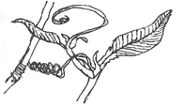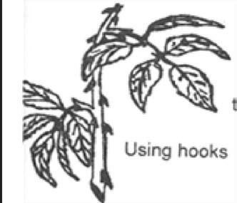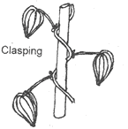

### How plants climb others

Plants with weak stems climb other by;

### Use of tendrils

1. **Use of hooks**
2. **Twining or clasping**

**Note**:

⇒ Stem tubers are crops with underground swollen stems which store food.

⇒ Plants with such include; cocoyam and Irish potatoes

⇒ Rhizomes commonly grow horizontally under the ground with stored food. E.g. ginger and canalily.

⇒ Corms grow vertically under the ground with stored food rich in carbohydrates.

### Learner’s activity:

1. In **one** sentence explain why plants climb others.
2. Using a diagram, show how plants climb others by clasping
3. Explain the term stem tubers
4. Apart from ginger and zoysia grass, mention any **one** other example of a rhizome.
5. Write any **two** ways in which stems are useful to;
   1. Plants
   2. People

## **CORRECTION**

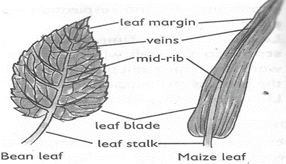

### PLANT LEAVES

* Leaves are the green parts of a plant with stomata for gaseous exchange.
* Leaves have chlorophyll to trap sunlight energy and manufacture its starch.
* Leaves also form the shoot system of a plant.
* A leaf is fixed between two internodes on a plant stem or branch.

### A drawn structure showing a leaf.

**Functions of the above parts.**

1. It has a surface area for easy trapping of sunlight energy by the help of chlorophyll
2. It’s where the stomata are found.
3. It helps in the manufacturing of starch

### Stomata

It’s called stoma for singular and stomata for plural.

They are small holes on the leaf where gaseous exchange takes place.

### Leaf veins.

They are hollow to allow distribution of water and nutrients within the leaf

### Leaf apex.

It’s the sharp tip part of a leaf to provide protection to the leaf

### Leaf stalk / petiole

This provides attachment of the leaf to stem or a branch.

**Note:** there are mainly two processes that take place in plant leaves namely; Photosynthesis and Breathing

### Learners Activity

* 1. Identify **two** important processes that take place in plant leaves.
  2. Draw and name parts of a leaf
  3. State the functions of the following parts of a leaf;
     1. Veins
     2. Chlorophyll
     3. Petiole
  4. How can plant leaves be useful to people?

## **CORRECTION**

### TYPES OF LEAVES

**Types of plant leaves**

1. Simple leaves
2. Compound leaves

### Simple leaves

Simple leaves are leaves that have one leaflet on each leaf stalk or lamina.

### Examples of simple leaves include;

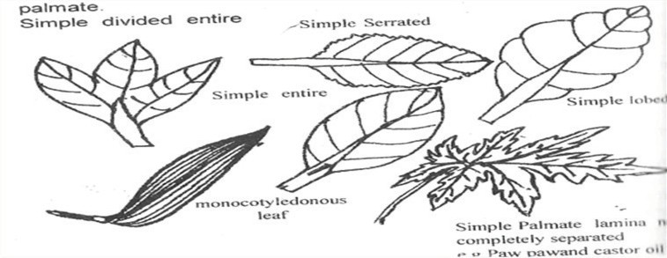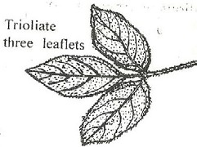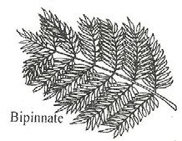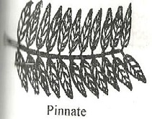

* Simple serrated leaf
* Simple palmate leaf
* Simple divided entire leaf
* Simple lobed leaf
* Simple entire leaf

### Drawn structure showing different examples of simple leaves

**Compound leaves**

* Compound leaves have more than one leaf-let on one leaf blade or stalk.
* Each leaflet has a small stalk which is attached to a common leaf stalk.

### Examples of compound leaves;

* Compound trifoliate e.g. Beans leaves
* Compound bipinnate. Jacaranda leaves/ mimosa plant
* Compound digitate leaf e.g. Silk cotton leaves
* Compound pinnate e.g. acacia leaves /eucalyptus

### Drawn structures showing examples of compound leaves

|  |  |  |  |
| --- | --- | --- | --- |
| Bipinnate | Pinnate | Trifoliate | Digitate |
|  |  |  |  |

**Leaf venation**

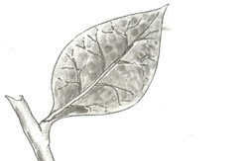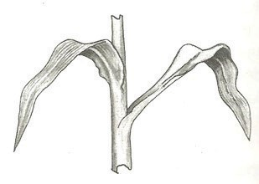

* Plant leaf venation refers to the arrangement of veins in a leaf.
* Veins in a plant leaf help in the distribution of water and mineral salts and translo- cation.

### Types of leaf venations:

1. Network leaf venation
2. Parallel leaf venation

Network leaf venation is a characteristic of dicotyledonous plants.

### A drawn structure showing a network leaf venation of a plant leaf.

**Note**:

* Network leaf venation is common in both simple and compound leaves.
* Parallel leaf venation is a characteristic of monocotyledonous plants.

### Drawn structure showing a leaf with parallel leaf venation.

**Importance of leaves to people**

* People eat leave as food.
* People use leaves as herbal medicine.

### Importance of leaves to plants:

* Leaves are used for photosynthesis.
* Some leaves store food for the plant.

### Learner’s activity

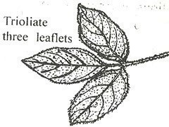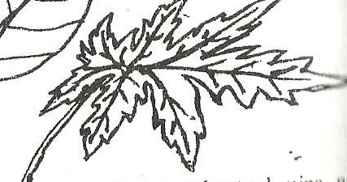

1. Write **one** sentence to show the meaning of the following;
   1. Venation
   2. Parallel venation
2. Draw the structure of a simple lobed leaf
3. Give **two** examples of compound leaves
4. Which of the leaves **A** and **B** is a compound leaf?

### A B

## **CORRECTION**

### PHOTOSYNTHESIS IN PLANTS

**Photosynthesis in plants**

* Photosynthesis is the process by which plants manufacture their own food by the help of sunlight energy.
* The word “photo” means light, “synthesis” means to make or “buildup”

### Raw materials needed

There are two raw materials needed during the process of photosynthesis.

### Water

### Carbon dioxide gas

* This is synthesized to make carbon
* Both water and carbon dioxide combine to build up glucose stored in the plant leaves as starch.

### Conditions necessary for photosynthesis

* Chlorophyll – to trap the sunlight energy
* Sun light energy – provides energy needed to speed up the formation of the starch.

### Note:

* Oxygen is a by-product of photosynthesis while starch is the main product.
* Animals get oxygen from the process of photosynthesis.
* Photosynthesis cannot take place at night due to the absence of the sunlight energy.
* Photosynthesis is a chemical change in plants.

### Learner’s activity.

1. Write **one** word to refer to the process by which plants make their own food
2. Write any **one** raw material for the process above
3. State **one** way in which the following can be useful during photosynthesis;
   1. Sunlight
   2. Water
4. Apart from oxygen, mention any other product of photosynthesis
5. Briefly explain why photosynthesis cannot take place at night.

## **CORRECTION**

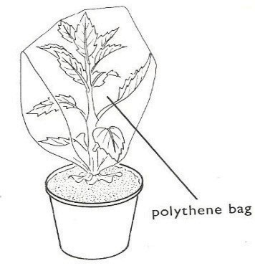

### LESSON4: TRANSPIRATION IN PLANTS

* Transpiration is the process by which plants lose water as vapour into the atmos- phere
* Transpiration takes place in plants through the stomata of leaves, lenticels and in the cuticle of stems.

Water droplets

### Factors that affect the rate of transpiration in plants; Wind

* Wind blows off the water vapour on the plant leaf giving chance or space for more vapour to come out. This increases the rate of transpiration.

### Humidity:

* Humidity is the amount of water vapour in the atmosphere.
* High rate of humidity lowers the rate of transpiration and vice versa.

### Temperature:

* High temperature during hot days causes plant leaves to lose a lot of water than on cool days.

### Sunlight:

* Heat from the sun causes the opening of the stomata, lenticels and cuticle hence creating more chances of losing water.

### Surface area of the leaf:

* Plants with small surface area of their leaves lose water at a lower rate than those with larger leaf surface area.

### Number of stomata:

* The more the stomata, the higher the rate of transpiration and vise versa

### Types of transpiration:

1. Stomatal transpiration
2. Cuticular transpiration
3. Lenticular transpiration

### Note:

* **In stomatal transpiration** plants lose water through stomata.
* **In cuticular transpiration** plants lose water through the cuticle of stems.
* **In lenticular transpiration** plants lose water through lenticels.

### Importance of transpiration to the environment

* 1. Transpiration promotes capillary attraction.
  2. Transpiration helps in cooling the plant during a hot day.

### Importance of transpiration to the environment

The transpired vapour from the plants helps in the formation of rain.

### Dangers of transpiration

* Excessive transpiration makes plants to dry (wilt)
* It lowers the crop yields due to less water left in the plant.

### Ways plants reduce the rate of transpiration.

* Some plants reduce the rate of transpiration by shedding their leaves especially dur- ing dry season e.g. deciduous plants (Mvule, Oak& fig trees)
* Stems have tough cuticles and lenticels to guard against water loss.
* Some plants curl their leaves
* Some plant leaves have few stomata and distributed at the lower part of the leaf.
* Some plants have leaves with a small surface area to reduce transpiration.
* Leaves have a wax-like layer to cover their stomata to limit the water loss.

### Learner’s activity.

* + 1. Briefly explain the term transpiration
    2. Cite out any **two** factors that affect the process of transpiration
    3. Give **two** ways in which transpiration can be useful to a plant
    4. Explain any **two** ways in which transpiration can be a disadvantage to a plant.
    5. Make an illustrative drawing to show that a plant shoot transpires

## **CORRECTION**

### Buds:

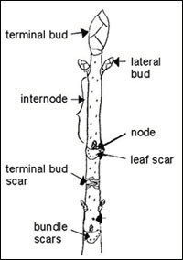

* A small part on a plant that grows into flowers, branches and leaves

### Types of buds

1. **Terminal buds**

* These are the main growing tips of a plant shoot.

### Axillary buds

* These are buds which grow into branches and flowers.

### Illustrations showing buds

**mportance of buds to plants**

* Buds develop into branches and flowers.

### LESSON 5: FLOWERS

* The flower is the reproductive part of a flowering plant.

### Pistil (female part)

* Pistil is made up of stigma, style, ovary and ovules

### Illustration of a pistil:

**Stamen (male part)**

* Stamen is made up of the filament and anther head.
* The male reproductive cells are the pollen grains and female are the ovules.

### Illustration of a stamen:

**Drawn structure showing parts of a flower.**

stamen anther filament

stigma style

ovary

carpel

ovule

petal sepal

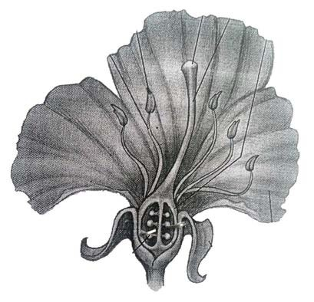

### Functions of the parts

* 1. **Petals**, the brightly coloured petals help to attract pollinating agents such as in- sects.

A group of petals is called ***corolla***

* 1. **Sepals**- Green sepals help to manufacture food for the plant.

Protect the inner parts of the flower at an early stage (bud stage)

A group of sepals is called ***calyx***

* 1. **Stigma**. Its function is to receive pollen grains

Pollen grains develop pollen tubes and grow down into the ovary

* 1. **Style**: is a passage of the pollen grains to the ovary.

The style also supports / holds the stigma in position.

* 1. **Ovary**. It produces the female gametes called ovules.

A fertilized ovary develops into a fruit.

* 1. **Filament**. Holds the anther in position.
  2. **Anthers**. Produce and store pollen grains.

### Importance of flowers to plants

Flowers help plants to reproduce

### Importance of flowers to people

* Some flowers are eaten
* Some flowers are used for decoration.
* Flowers are used to make perfumes.

### Learner’s activity.

* + 1. What scientific name is give to a group of;
       1. Petals :
       2. Sepals :
    2. Of what importance are brightly coloured petals to a plant
    3. Give **two** uses of flowers to human beings
    4. Draw and name parts of a female part of a flower

## **CORRECTION**

### LESSON 6: POLLINATION

* Pollination is the transfer of pollen grains from the anther to the stigma of a flower on a plant.
* Pollination helps to allow fertilization in plants
* The pollen grains are the male gametes while the ovules are the female gametes in plants.

### Types of pollination

There are two types of pollination namely;

1. Self pollination
2. Cross pollination

### Self pollination:

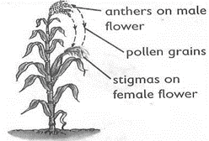

Self pollination is the transfer of pollen grains from the anthers to the stigma of flowers on the same plant

### Characteristics of flower that undergo self pollination:

* Flowers with self pollination have shorter style compared to their filaments
* They also have brightly coloured petals to attract pollinators

### Note:

Some flowers are adapted to self pollination by:

* Both the anther and stigma maturing at the same time.
* Their flowers remain closed until self pollination takes place

### Structure illustrating self-pollination.

**Cross pollination**

* Cross-pollination is the transfer of pollen grains from the anther heads the stigma of a flower on another plant but of the same type or species.
* In cross–pollination, the filaments are shorter than the style.

### Adaptation of some plant to cross pollination

* The anthers and stigma mature at different times e.g. maize plant.
* When pollen grains land of the stigma of the same flower they don’t develop pollen tubes
* The male and female parts of a flower grow on different plants e.g. papaw plant

### Illustration showing cross-pollination.

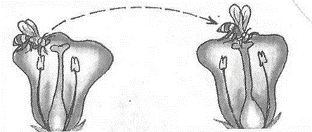

**Agents of pollination:**

Agents of pollination refers to the factors that are responsible or cause pollination to take place.

### These include;-

* Wind
* Insects
* Birds

### Note:

* Insects that pollinate flowers include; bees, butter flies and moths which pollinate flowers at night.
* Birds that pollinate flowers include; sun bird and humming birds

### Characteristics of insect-pollinated flowers

* They have scent.
* They have brightly coloured petals.
* They produce sticky pollen grains.
* They have sticky stigma.

### Characteristics wind pollinated flowers

* They produce a lot of pollen grains,
* They have no scent,
* They have dull petals
* They don`t produce nectar.

### Learner’s activity.

1. Briefly explain the term pollination
2. Name the agents of pollination
3. Identify **two** factors that favour;
   1. Self-pollination
   2. Cross-pollination
4. Give any **one** difference between insects and wind pollinated flowers

## **CORRECTION**

### SEEDS

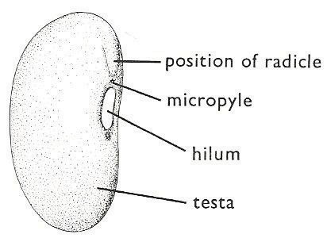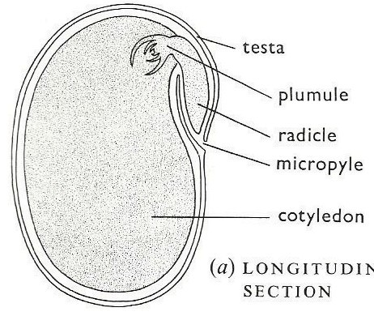

* A seed is a fertilized ovule.
* A seed develops into a young plant or a seedling under favourable conditions.

### Dicotyledonous seeds

Dicotyledonous seeds are seeds with two cotyledons

### Examples include:

* Bean seeds
* Peas
* Groundnut seeds

**NB:** All dicotyledonous seeds undergo epigeal germination.

### A drawn structure showing parts of external and internal parts of a bean seed.

|  |  |
| --- | --- |
| **External Parts** | **Internal parts** |
|  |  |

**Monocotyledonous seeds:**

Monocotyledonous seeds are seeds with only one cotyledon.

### Examples include;

* Maize,
* Millet,
* Sorghum, etc.

**NB:** Monocotyledonous seeds undergo hypogeal germination.

### Drawn structures showing external and internal parts of a maize grain.

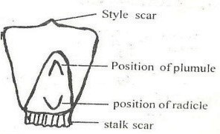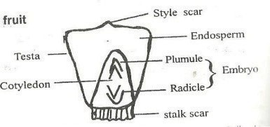

|  |  |
| --- | --- |
| **External parts** | **Internal parts** |
|  |  |

**Functions of the above parts.**

1. **Seed coat (testa)**

* It protects the inner delicate parts of the seed.

### Cotyledon

* Absorbs stored food from the endosperm to the embryo during germination.

### Endosperm

* Stores food in monocotyledonous seeds.

### Plumule

* It grows into shoot system

### Radicle

* Grows into the root system.

### Micropyle

* Is a passage of air and water to the seed embryo.

### Importance of seeds to plants:

* Seeds help plants to multiply in number.

### Importance of seeds to people

* Seeds are eaten as food.
* People sell seeds and get money.

1. Why a maize grain is called a fruit?
2. Use **two** ways in which seeds are useful to people
3. Draw and name the following parts of a bean seed.
4. Micropyle
5. Hilum / scar
6. Testa
7. State the functions of the following parts of a maize grain.
   1. Endosperm :
   2. Cotyledon :
   3. Stalk scar :
8. State the functions of the following parts of a maize grain.
   1. Endosperm :
   2. Cotyledon :
   3. Stalk scar :
9. Draw and name the following parts of a bean seed.
10. Micropyle
11. Hilum / scar
12. Testa
13. Write any **one** difference between monocotyledonous and dicotyledonous seeds

# CORRECTION

### GERMINATION IN PLANTS

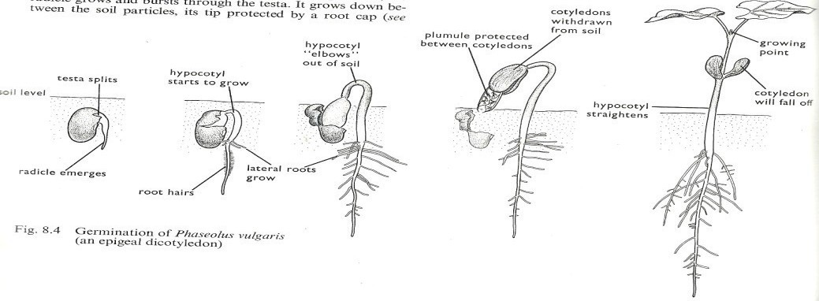

Germination is the development of a seed embryo into a seedling.

### Note:

During germination, the Radicle grows into the root system to support the seedling firmly into the soil.

The radicle also grows root hairs to absorb water and mineral salts from soil.

### Types of germination

1. Epigeal germination
2. Hypogeal germination

### Epigeal germination:

* Epigeal germination is a type of germination where the cotyledon comes out of the ground.
* Epigeal germination is a common characteristic of dicotyledonous seeds e.g. Beans, soya beans, groundnuts.

### Drawn structure showing the different stages in Epigeal germination.

**Hypogeal germination**:

* This is a type of germination in which the cotyledon remains under the ground
* This type of germination is a common characteristic of monocotyledonous seeds e.g. maize, millet, rice, sorghum

### Stages involved in Hypogeal germination.

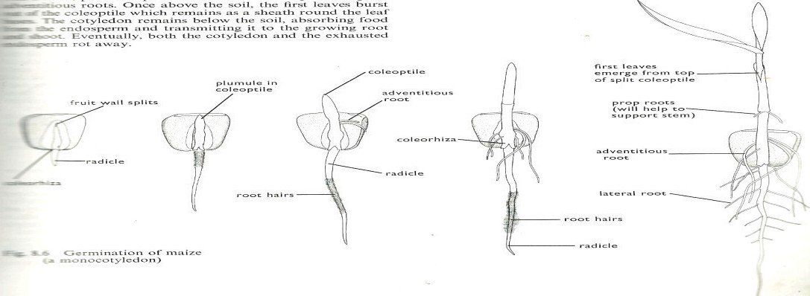

**Conditions necessary for seed germination.**

1. Oxygen
2. Water
3. Warmth (Optimum temperature).

### Seed viability:

Seed viability is the ability of a seed to germinate under favourable conditions.

### A viable seed should be;

* Mature and dry
* Whole without a hole / wrinkles
* Healthy and of a good variety

### Learner’s activity.

1. State what you understand by germination of seeds
2. Point out any **two** conditions necessary for seed germination.
3. Using diagrams, show the different stages of a germinating bean seed
4. List any **two** characteristics of a viable seed
5. If a seed is not viable, it’s said to be dormant. What does seed dormancy mean?

# CORRECTION

### Tropism:

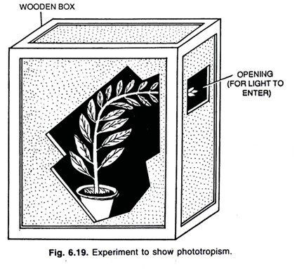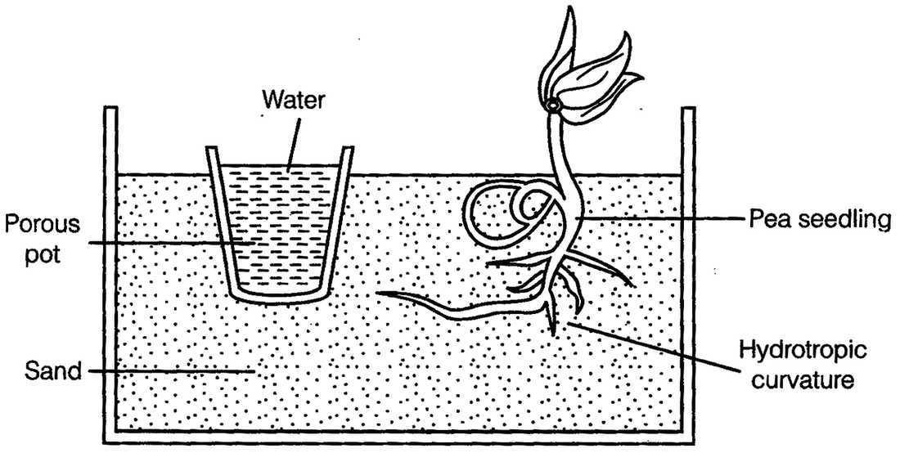

* Tropism is the plants growth movement in response to stimulus (change in the envi- ronment)

### Phototropism:

* This is the plant’s growth movement towards the source of light.

### Illustration:

**Hydrotropism**

* This is the plant’s growth movement towards the source of water.

### Illustration:

**Geotropism:**

* This is the plant’s growth movement towards the direction of gravity force.

### Thigmotropism:

* This is the plant’s growth movement in response to the direction of touch.

### Chemotropism

* This is the plant’s growth movement towards the source of chemical.

### FRUITS

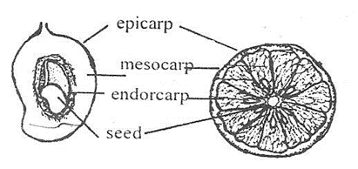

* A fruit is a fertilized ovary
* A fruit is any structure in flowering plants that contains seeds
* A fruit has two scars i.e. style scar and stalk scar.

### Fruits are divided into two;

* Succulent fruits (Juicy fruits)
* Dry fruits (Non juicy fruit)

### Succulent fruits

Succulent fruits are groups of fruits with juicy pericarps and are eaten.

**These include** berries, pomes and drupes

* *Berries* are succulent fruits with many seeds like guavas, tomatoes, oranges etc.
* *Drupes* are succulent fruits with only one seed such as avocado fruit and mango fruit.
* *Pomes* are succulent that develop from the receptacle

### Drawn structure showing the different parts of a juicy fruit (mango and orange)

**Dry fruits**

These are fruits whose pericarp is usually dry hard and woody.

### They are divided into two namely;

1. Splitting (dehiscent fruits)
2. Non-splitting (indehiscent fruits)

### Splitting (dehiscent fruits)

*Splitting fruits* have capsule or pods that split to disperse their seeds when dry. E.g.

Beans, peas and castor oil.

### Non-splitting (indehiscent fruits)

* *Non-splitting fruits* have one seed only.
* Their pericarp does not split to disperse the seeds but have structures for their mode of dispersal. Eg. Black jack, maize, sunflower, tridax etc.

### Note:

* Some fruits develop from one flower. They are called *simple fruits*.
* Sometimes all flowers on a stalk make one fruit. Such fruits are called *compound* or

*multiple fruits* e.g. Pineapple.

Some fruits are not formed from the ovary of a flower but from some other parts of a flower. Such fruits are called *false fruits*. E.g. an apple which develops from a recep- tacle

### Learner’s activity.

1. Briefly explain the following terms;
   1. A fruit
   2. Dehiscent fruits
   3. Multiple fruits
2. Cite out **one** example of a false fruit
3. Write **one** way in which black jack is different from castor oil.
4. List **two** functions of fruits to plants
5. Give **two** examples of juicy fruits

**CORRECTION**

### SEED DISPERSAL

Dispersal is the scattering of seeds from the parent plant to other areas.

### Agents of seed and fruit dispersal

* Animals
* Wind
* Flowing water
* Self-dispersal or explosive mechanism

### Importance/advantages of seed and fruit dispersal

* Dispersal enables plants to colonize new areas
* Dispersal reduces competition for light and the nutrients among plants.
* Dispersal increases the chances of the plant survival.

### Types or mechanisms of seed dispersal are;

1. Wind dispersal
2. Animal dispersal
3. Water dispersal
4. Explosive mechanism.

### Characteristics of seeds dispersed by animals

* They have juicy mesocarp
* Some have hook-like structures to attach them on the animals’ bodies
* Some have hard seed coats to protect them from the digestive juices.

### Examples of seeds dispersed by animals are;

* Mango fruit
* Guava fruit
* Jack fruits
* Avocado fruit etc.

### Characteristics of seeds dispersed by wind

* Many are small and light to be easily carried by wind.
* Some seeds have wing-like structures for floating in air e.g. jacaranda
* Some have a parachute hair structure e.g. dandelion
* Some have a tuft of hair e.g. cotton seeds

### Note:

Seeds dispersed by ***explosive mechanisms*** split their pods when ripe and disperse their seeds.

These include; castor oil, peas and beans.

**Characteristics of Seeds dispersed by *flowing water***

* These seeds have numerous air spaces with an air tight covering
* Examples include; Water lilies and coconut fruits.

### Learner’s activity.

1. Write **one** word to mean the scattering of seeds from one mother plant to other areas
2. Write any **two** methods of seed dispersal
3. Give **two** ways in which seed dispersal can be useful to plants
4. List **two** differences between wind and animal dispersed seeds

## **CORRECTION**

1. Draw the structure of a tridax

### NON-FLOWERING PLANTS

Non-flowering plants are groups of plants that do not bear flowers.

Groups of Non-flowering plants

1. Spore producing.
2. Coniferous plants**.**

### Non-flowering

Spore producing Coniferous plants**.**

### Mosses Ferns Liverworts Pine Cedar tree Cypress Spore producing:

* Spore producing plants are groups of non-flowering plants that reproduce by means of spores.
* A spore is a single cell that can develop into a new plant under favorable conditions.

**Examples of spore producing plants include;** liverworts, mosses and ferns.

* Ferns are the most advanced group of spore producing plants with proper leaves, stems and roots.
* Mosses are small green cushion-like and grow commonly on house roof verandas, tree trunks, and in damp soils.
* Liverworts have leaf like structures and commonly grow in wet moist places.

### Illustrations showing different examples of spore producing plants.

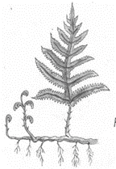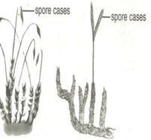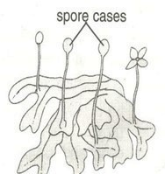

**Fern plant Mosses plant Liverwort plant**

**Note**:

All spore producing plants are green and therefore able to make their own food.

### Conifers or Coniferous plants:

* Coniferous plants are non-flowering plants that reproduce by means of seeds pro- duced in hard structures called cones.
* Conifers have roots, stems and small needle shaped leaves

### Examples of coniferous plants include

* Pines * Cypress
* Cedar tree * Fir tree
* Podo tree * Ginkgo

### Importance of conifers

* 1. Some are planted in compounds to provide shade and also act as wind breaks.
  2. Some conifers are planted around the compounds and farmers to act as live fences
  3. They are sources of soft wood timber

### Learner’s activity.

* + 1. In **one** sentence show the meaning of non-flowering plants
    2. Mention the **two** main groups of non-flowering plants
       1. (ii)
    3. Conifers cannot bear flowers. How do they reproduce?
    4. State **two** ways in which coniferous plants can be useful to people
    5. Briefly explain why algae are not classified as plants.
    6. How can algae be useful to an industrialist who deals in food processing?

## **CORRECTION**

### PLANT PROPAGATION

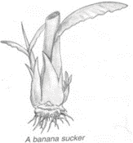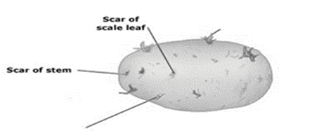

Propagation is a way obtaining a new plant from an existing plant.

### Types of propagation

* Natural propagation (seed propagation) – involves the use of seeds for reproductive part of a plant

### Vegetative propagation (artificial propagation)

This refers to asexual reproduction in which part of a plant used to obtain a new plant is not from a flower (productive part)

### Types of vegetative propagation

1. Natural vegetative propagation
2. Artificial vegetative propagation

### Examples of natural vegetative propagation

* 1. **Use of suckers**
* Some plants are propagated using suckers such as; bananas, pineapple and sisal

### A structure showing a sucker of a banana plant.

* 1. **Use of tuber**
* Some plants are propagated using tubers such as; Irish potatoes, cocoyam.

### A structure showing parts of stem tuber.

**lateral bud** ‘eye’

**scale leaf**

### Use of corms

* Some plants are propagated with the help of corms (kind of underground stems) e.g. coco yams, gladiolus and crocus.

### Use of rhizomes

* Some plants are propagated using the rhizomes.
* Rhizomes are swollen underground stems with stored food and grow horizontally.

**Example include**, ginger, zoysia grass and turmeric.

### Use of bulbs

* Some plants are propagated using bulbs such as onions
* A bulb is a short, thick underground stem with scaly leaves containing stored food.

### A structure showing a bulb:

Foliage leaves

Terminal bud

Axillary bud or lateral

Scaly leaves

Fleshy leaves (storage) stem

Adventitious roots

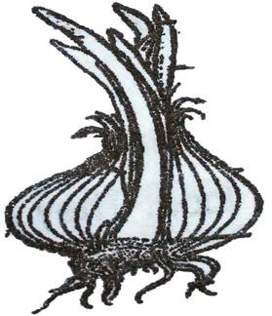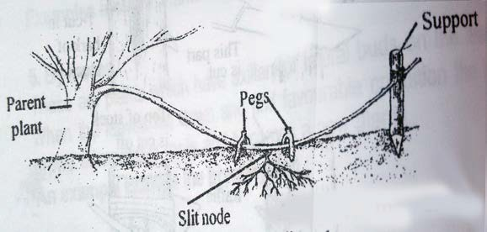

### Examples artificial vegetative propagation

* + 1. **By stem cutting**
* Some plants are propagated by using stem cutting such as cassava, sweet potatoes and sugar cane.

### By layering

* Layering is when a shoot is pegged down to the soil

### A structure showing layering

1. **Marcotting**

* Marcotting is a way of propagating plants by making a shallow cut at the node, cov- ered with soil, adventitious roots grow from the cut then it is cut from the parent plant to another place.

### A structure showing marcotting

1. **By budding**
2. **By grafting**

* This where a shoot of one plant with a bud is tied onto a stem of another plant and both continue to grow.

### A structure showing grafting

**Advantages of vegetative propagation**

1. In vegetative propagation plants mature in a short time.
2. The new plants maintain the original characteristics of the parent plant e.g. re- sistance to pests and diseases.

Advantages of seed propagation over vegetative propagation

### Learners activity

1. State what you understand by the term plant propagation
2. Give **two** methods of plant propagation
   1. (ii)
3. State how the following plants can be propagated;
   1. Sweet potatoes :
   2. Sisal :
4. Give **two** advantages of vegetative propagation over seed propagation.
5. Name any **one** crop raised in a nursery bed

## **CORRECTION**

# CORRECTION

**CORRECTION**

### TOPIC 2 : KEEPING CATTLE IMPORTANCE OF KEEPING CATTLE

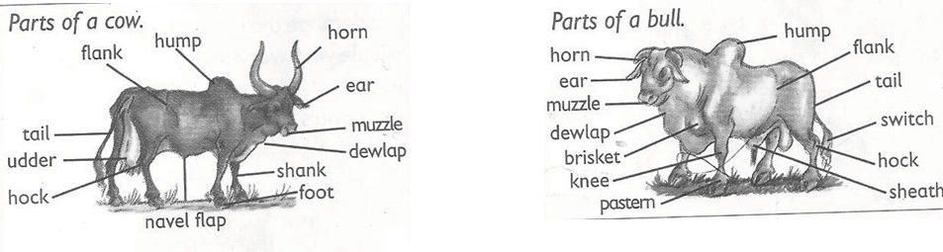

* Keeping cattle refers to the act of rearing bulls, cows, calves and heifers.
* Animal husbandry refers to the act of rearing farm animals or livestock.

### Farm animals include;-

* Pigs *Goats * Rabbits
* Sheep * Cattle

### A drawn structure showing the external features of a cow and a bull.

**Importance of keeping cattle.**

The following are the reasons why people keep cattle;

* Cattle provide people with milk and meat which are sources of proteins.
* Waste materials (dung) from cattle acts as natural manure used to improve soil fer- tility
* Hooves and horns are used to make enamel items like plates and cups.
* Hides from cattle are used in making leather products.
* Cow dung can be used in building local houses and making biogas
* Keeping cattle is a source of employment.

### Learner’s activity.

1. Write one sentence to show the meaning of the following terms;
   1. Keeping cattle
   2. Animal husbandry
2. State **one** reason why many Ugandan have taken up cattle keeping as a business
3. What is the importance of horns and hides to an industrialist

**CORRECTION**

### TYPES OF CATTLE

A type of cattle is a class of cattle kept for a specific purpose. Specific purpose may be;

* For milk production
* For meat (beef) production
* For provision of animal labour
* For both milk and meat production

### Types of cattle

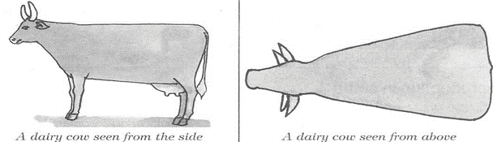

There are basically three types of cattle namely;

1. Dairy cattle – kept for milk production
2. Beef cattle -- kept for beef (meat) production
3. Dual-purpose cattle -- kept for the both milk and meat production.

### Dairy cattle

* This a type of cattle kept specifically for milk production.

### Characteristics of dairy cattle.

* They produce much milk.
* They have a triangular shape.
* They have big (large) udders
* They have small necks.
* They have long legs.

### A drawn illustration showing body shape of dairy cattle.

**Examples of dairy cattle include.**

* Friesian
* Ayrshire
* Guernsey
* Jersey
* Jamaican hope
* Brown Swiss cattle.

### Beef cattle

This is a type of cattle kept mainly for beef production.

### Characteristics of beef cattle;

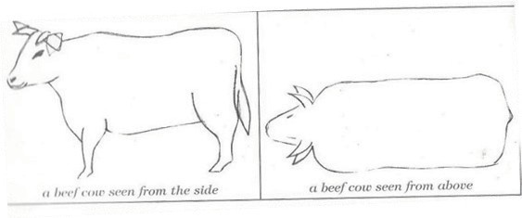

* They produce little milk.
* They have a rectangular body shape.
* They produce much meat.
* They have small udders.
* They have large necks.
* They have short legs.

### An illustration showing the body shape of beef cattle.

**Examples of cattle kept for meat production include**;

* Aberdeen angus (weighs 720-900kgs)
* Hereford (weigh about 1000kgs)
* Charolais (creamy in colour)
* Beef shorthorn
* Galloway (it’s small and long haired black)
* American brahman cattle

### Dual purpose cattle

These are groups of cattle kept for both milk and meat production

### Examples include

* Sahiwal (its brown –red in colour and large in size)
* Red poll (has a medium size with no horns)
* Milking short horn (don’t grow very fast like others but produce hard meat)

### Note:

Dual Purpose Cattle have characteristics of dairy cattle and beef cattle

### Learner’s activity

1. What do you understand by the term type of cattle?
2. List any **two** types of cattle
   1. (ii)
3. Identify the type of cattle with a rectangular body shape
4. Give **two** examples of dairy breeds of cattle
   1. (ii)
5. Name the commonest exotic dairy breed of cattle reared in your locality

## **CORRECTION**

### BREEDS OF CATTLE

**A breed of cattle** is a family or group of cattle having specific characteristics.

### Specific characteristics may include;

* Colour of cattle
* Size of the animals
* Productivity of the animals.

### Types of Breeds of cattle include;

* Local breeds of cattle (indigenous)
* Exotic breeds of cattle
* Cross breeds

### Local breeds of cattle (indigenous)

* Local breeds or indigenous cattle are breeds of cattle that have lived in East Africa for a long time. They are also called the native breeds kept for both milk and meat production.

#### Examples include;

* Small east African zebu
* Boran cattle.
* Nsagala or sanga cattle
* Ankole cattle

### Characteristics of local breeds of cattle.

* They are resistant to tropical diseases
* They have the ability to walk long distances
* They can withstand hash weather conditions
* They can survive on poor pasture and less water

**Disadvantages of local breeds of cattle** They produce less meat and milk They have a slow growth rate

They produce less products (meat and milk)

### Exotic breeds of cattle

* These are groups of cattle breeds imported into East Africa.
* They are either dairy, beef or dual-purpose cattle

#### Examples include;

* Friesian, Ayrshire, Guernsey Jersey, Jamaican hope, brown swiss, Aberdeen angus, Hereford, Charolais, Shorthorn, Galloway and American beef master

### Characteristics of exotic breeds of cattle.

* They grow quickly with no horns
* They are not resistant to diseases.
* They need a lot of attention or care.
* They produce high quantities of milk and beef
* They need a lot of water and good pasture

### Note:

**Cross breeds** are obtained after mating a local breed with an exotic breed.

* This is the best way of improving upon the poor local breeds of cattle.

### Learner’s activity.

1. Give the difference between a breed of cattle and a type of cattle
2. Mention any **two** breeds of cattle commonly kept in Uganda
   1. (ii)
3. Identify a breed of cattle you would prefer to keep in your locality
4. Give a reason for your answer in (3) above
5. Cite out the best way of improving on our local breeds of cattle

## **CORRECTION**

### LESSON4: BREEDING IN CATTLE

**Breeding**

This is the act of maintaining or improving the desired characteristics in cattle.

### Desired characteristic may include;

* Size of the animal.
* Resistance to diseases.
* Animal’s skin colour
* Productivity of the animals

### Types of breeding

1. Line breeding
2. Inbreeding
3. Cross-breeding
4. Out breeding
5. Upgrading
6. ***Line breeding*** is the act of mating closely related animals such as cousins.

This type may result into poor production in animals

1. ***Inbreeding*** is the continuous mating of very closely related animals such as brother and sister animals.

This method if not properly practiced, it may also produce poor quality animals.

1. ***Out breeding*** is the practice of mating distantly related animals

This method helps to restore the qualities in cattle that may be disappearing from a flock.

1. ***Cross breeding*** is the practice of mating a local breed with an exotic breed of cat- tle.

After cross breeding, a cross-breed is obtained or a hybrid. Cross-breeding helps to improve animals with poor qualities

1. ***Upgrading*:** this is the act of improving upon the qualities of one breed by using a male animal of superior qualities several times.

### Importance (advantages) of breeding

* Breeding helps to improve animals with poor qualities
* Breeding helps to obtain hybrids.
* Breeding helps to maintain good characteristics in animals

### Learner’s activity

1. In **one** sentence show the meaning of breeding as used in cattle keeping
2. List down **two** types of breeding in cattle
   1. (ii)
3. State why inbreeding is discouraged in the management of cattle breeding
4. How can a local farmer improve on his local breeds of cattle
5. Briefly describe how a hybrid is obtained.

## **CORRECTION**

### The reproductive system of a cow.

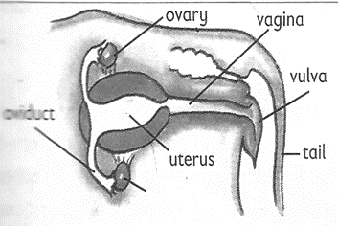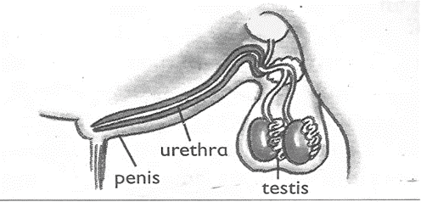

**Functions of different parts**

***Vulva*:** receives and guides the penis

***Vagina*:** it’s where semen is deposited

***Cervix*:** closes the lower end of the uterus during pregnancy

***Ovary*:** produces the ova and hormones that help to control the sexual cycle

***Ova*:** are the reproductive cells produced by the ovary ***Oviduct*/*fallopian tube*:** Is the place where fertilization takes place. ***Uterus*:** it’s where implantation takes place (development of the foetus) **Reproductive system of a bull**

Sperm duct

Scrotum

Sheath

testes

**Functions of parts *Testes*-** produce sperms ***Sperm ducts*** – carry sperms

***Urethra***– passes out urine and sperms

***Penis*** – delivers semen in the vagina of a cow

### Learners Activity

1. Draw the female reproductive system of a cow and name the following parts
   1. Oviduct
   2. Vulva
   3. Uterus
2. Using an arrow, show on your diagram the part where implantation takes place.
3. Write the function of the following parts of the system;
4. Cervix :
5. Testis :
6. Ovary :

## **CORRECTION**

### LESSON 6: HEAT PERIOD AND INSEMINATION (SERVICES)

**Heat Period (oestrus)**

* This is the time when a cow is in need of a bull for mating.
* Mating takes place only when a cow is on heat.

### Signs of a cow on heat

* The cow becomes restless
* The cow mounts other cattle and stands still when bulls mount it
* The cow urinates frequently
* The cow puts its tail on the side to enable its vulva to be seen
* There is a mucus discharge from the vulva
* Its vulva swells and changes its colour
* There is a drop in its milk production
* The cow makes a lot of noise (Bellows frequently)

### Insemination (service)

* *Insemination or* service is the act of depositing sperms into the reproductive organ a female animal.

### Types of insemination

1. Natural insemination
2. Artificial insemination

### Hand mating

* This means bringing a bull to mate with a cow on heat.

### Pasture Mating

* This means allowing a bull to move with cows so that it mates easily with those on heat.

### Advantages include;

* Natural insemination saves time
* It does not need a trained inseminator in order to carry it out.

### Disadvantages

* More sperms are wasted in one cow.
* It’s very expensive to buy and maintain a bull
* Big bulls can cause injuries to weak cows
* Once the bull dies, sperms are also lost.

### Artificial insemination

* Refers to the act of depositing semen in the vagina of a female animal of (cow) by the help of a trained veterinary officer.
* Semen used is got from health bulls and with desired characteristics.
* Sperms are deposited into the vagina using an insemination syringe.

### Advantages

1. It reduces the cost of keeping many bulls on the farm,
2. It’s cheaper to buy semen than buying and maintaining a bull.
3. It prevents injury to small cows and heifers by bigger or heavy bulls.
4. It helps to control inbreeding and unwanted pregnancies in cattle
5. It promotes selective breeding.

### Disadvantages;

1. It’s difficult and expensive to maintain proper storage of sperms.
2. It can’t be applied to animals whose signs of heat can’t be easily identified.
3. It requires a trained experienced inseminator Animals are denied chance to enjoy mating **Learner’s activity**
4. Briefly explain the term insemination
5. Give **two** ways in which natural insemination can be dangerous to a livestock farmer
6. How does artificial insemination control unwanted pregnancies on a farm.
7. Identify **three** signs of a cow on heat

## **CORRECTION**

### Fertilization in a cow

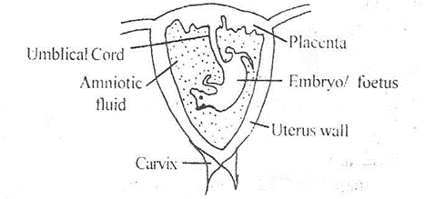

* Fertilization is the union of male and female gametes to form a zygote.
* A gamete is a reproductive cell.
* The female gamete is called Ovum
* The male gamete is called a Sperm.

### Diagram of a sperm and an Ovum

Sperm Ovum

### NB:

* After fertilization, the zygote develops into an embryo.
* The embryo develops into a foetus and finally into a calf.

### Zygote Embryo Foetus Calf

The embryo is attached to the uterus wall through the placenta.

### Implantation

* This is the attachment of the foetus to the walls of the uterus.

### Gestation period

* This is the time between conception and giving birth.
* The gestation period of an in-calf is 270-280 days or nine months.
* An in-calf is a cow that is pregnant.

### An illustration showing developing foetus

**Note:**

*The placenta* supplies oxygen and digested food to the foetus and also stores water from the foetus temporarily.

***Umbilical cord* is** a passage of food and oxygen to the foetus ***Umbilical cord*** also transports wastes from the foetus to the placenta. ***Amniotic fluid*** acts as a shock absorber for any external pressure.

### Signs of pregnancy:

* The uterus enlarges in the second and third month after conception.
* The udder enlarges and fills with milk.
* The cervix closes during pregnancy.
* The movement of foetus can be seen or felt after 7 months.

### Steaming up

* This is the feeding of an in-calf on foods rich in protein. It is normally done during the last two months.

### Why steaming up/advantages of steaming up

* It encourages the foetus to grow healthy.
* It builds a cow’s body in preparation for calving (parturition)
* It increases the manufacture of colostrums.
* It prevents low birth weight.
* It prolongs gestation period

### Dry period

* This is the time when a lactating cow is left without milking it in preparation to giv- ing birth.
* A cow is dried six to seven weeks before calving.
* During the dry period, the in-calf is fed on foods rich in protein.

### Calving or parturition

This is the act of giving birth in cattle (cows).

### Signs of calving

* The vulva swells and becomes red.
* The cow lies down most of the time.
* The udder and teats become swollen.
* The amnion (or water sac) busts and comes out

### Colostrums

This is the first milk got from a cow which has given birth.

### Uses of colostrums

* It has all food values needed by a young animal.
* It opens up the digestive system of a calf.
* It boosts the immunity of a calf since it is rich in antibodies.

### GRAZING /FEEDING IN CATTLE FEEDING IN CATTLE

The digestive system (stomach) of a cow (cattle)

* Cattle, sheep and goats are ruminant animals. They chew cud.
* They have four chambered stomachs. I.e. Rumen(pouch), Reticulum (honey comb), Omasum and Abomasum

### Illustration showing the stomach of a ruminant:

oesophagu~~s~~  omasum

rumen

### Functions of the parts:

1. **Oesophagus (gullet)**

reticulum

abomasum

duodenum

* This is the passage through which food (roughage) moves from the mouth to the ru- men.

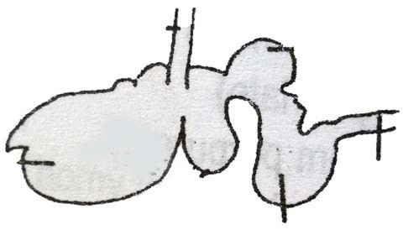

* Food (roughage) move by the process of wave like movement called peristalsis.

### Rumen (pouch)

* The rumen is the largest of the four stomachs
* It stores roughage temporarily before it is returned to the mouth for rumination (chewing cud)

### Reticulum (honey comb)

* This is second stomach where bacterial action takes place.
* It separates chewed materials from coarse ones.

### Omasum

* This is the third stomach. Its where absorption of water from food takes place.

### Reticulum

* This is the fourth stomach. It is called True stomach
* This is where chemical digestion takes place.

### Types of food stuffs

1. **Forages:**

These include hay (dried grass), pasture or green grass, legume, silage, (fermented grass) straws.

### Concentrates:

These include cereals, oilseeds and legume seeds.

### Supplements:

These include proteins and vitamins added to feeds.

### Additives:

These can be drugs and flavors added to feeds.

### Other feeds given to animals: Maintenance rations:

These are feeds given to animals to sustain their usual foods.

### Production rations:

These are extra feeds given to cattle for production of beef or milk.

### Salt supply:

This is salt given to animals to stimulate milk production.

### Note:

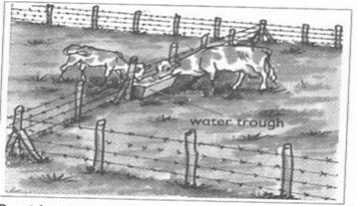

**Intake** – This refers to the amount of food eaten by an animal.

### Methods of grazing

There are three main methods of grazing cattle namely;

1. Rotational grazing
2. Zero grazing
3. Herding or free range system

### Rotational grazing

* This is the type of grazing where animals graze on one portion of pasture at a time. This can be done using the following systems;

1. Paddock grazing
2. Strip grazing
3. Tethering

### Paddocking

* This is when a farmer feeds his animals on pasture land divided into sections (paddocks) using a female
* Cattle are fed on grass in a paddock and when the grass is no longer enough they are moved to another paddock.

### An illustration of paddock grazing

**Advantages of paddock grazing**

* Paddocks help to control overgrazing
* Paddock grazing controls pests and diseases
* Paddock grazing enables the animals to have grass all the time.
* It lessens the labour used to look after the animals after setting up paddocks.
* Paddocks help to control the spread of diseases
* The dung and urine of the animals are evenly distributed. This allows for new grass to grow well in all paddocks.

### Disadvantages of Paddocking

* The materials needed are expensive
* Animals have no choice of the type of plants to eat
* It requires a big piece of land
* The barbed wires can tear the skin of the animals

### Strip grazing

This when an animal gazes when it is tied on a tree/peg using a rope

### Advantages

1. Pasture is evenly used
2. Diseases and vectors are controlled
3. Labour is reduced on the farm

### Disadvantages

* 1. It’s expensive to start and maintain
  2. It requires few animals to be kept

### Tethering

This when an animal grazes when it is tied on a tree/peg using a rope or chain This is the most common method used in East Africa .

### Advantages of paddock grazing

* Paddocks help to control overgrazing
* Paddock grazing controls pests and diseases
* Paddock grazing enables the animals to have grass all the time.
* It lessens the labour used to look after the animals after setting up paddocks.
* Paddocks help to control the spread of diseases
* The dung and urine of the animals are evenly distributed. This allows for new grass to grow well in all paddocks.

### Disadvantages of Paddocking

* The materials needed are expensive
* Animals have no choice of the type of plants to eat
* It requires a big piece of land
* The barbed wires can tear the skin of the animals

### Strip grazing

This when an animal gazes when it is tied on a tree/peg using a rope

### Advantages

1. Pasture is evenly used
2. Diseases and vectors are controlled
3. Labour is reduced on the farm

### Disadvantages

* 1. It’s expensive to start and maintain
  2. It requires few animals to be kept

### Tethering

This when an animal grazes when it is tied on a tree/peg using a rope or chain This is the most common method used in East Africa .

### A structure showing tethering method

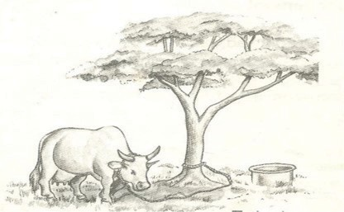

**Advantages of tethering method.**

* 1. It’s cheap and appropriate to maintain
  2. No fencing is required
  3. Pasture chosen by the farmer is always the best

### Disadvantages

* + 1. It can only work best for few animals
    2. Animal feeding is only limited to areas around the peg.
    3. It requires the farmer to keep transferring the animals when pasture reduces

### Learner’s activity

* + - 1. One sentence, show the meaning of the phrase rotational grazing
      2. Give **two** advantages of rotational grazing
      3. Identify any **two** methods of rotational grazing
      4. Briefly explain how strip grazing can be a disadvantage to a livestock farmer
      5. Give **two** advantages of paddock grazing to a farmer

## **CORRECTION**

### LESSON 3 : HERDING AND ZERO GRAZING

**Herding (free range grazing)**

* This is a system where animals are left free to graze on different types of pasture as they are monitored by a herdsman.
* This system is mainly practiced by Normadic pastoralists

### Advantages

* Animals are able to do some exercises as they graze
* It does not require any fencing
* The animals graze on different pastures of their choice

### Disadvantages

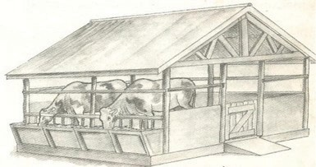

* Animals need a herdsman to look after them all the time
* Animals can easily stray and destroy farmer’s crops
* Inbreeding is difficult to control

### Zero grazing

* This is a system where animals are kept under a special structure and water or feeds are provided.
* Small cubicles are made for resting of the animals or feeding.

### An illustration of zero grazing

**Advantages of zero grazing**

1. It’s easy to collect manure (Farm Yard Manure)
2. Animals are easy to control and monitor
3. Feeds are not wasted since animals are given only what is enough.
4. Animals are protected from bad weather like sunshine and heavy rains

### Disadvantages of zero-grazing

1. It’s very expensive to start and maintain
2. The farmer gets over worked
3. There is easy spread of diseases and pests
4. It involves of either buying feeds or growing fodder crops
5. Much labour is required to feed and monitor the animals

### Learner’s activity

* 1. Explain the following terms;
     1. Herding :
     2. Zero grazing :
  2. Outline any **three** advantages of herding
  3. How can zero grazing be a disadvantage to a farmer?

## **CORRECTION**

### HOUSING OF CATTLE AND FENCING

Like any other animals, cattle need good housing. They should be provided with shelter for the following reasons;

1. To protect them from bad weather like heavy rain and strong sunshine.
2. To protect cattle from thieves and attacks by wild animals
3. To maintain their health and ease their feeding

### Qualities or characteristics of a good house of cattle (byre)

1. Well ventilated for free air circulation.
2. Has a strong floor made of concrete for easy cleaning.
3. Has a slanting to enable urine drain out.

### Materials used to build cattle houses include

Wood, concrete, metals, bricks, plastics, stones etc.

A fence is a barrier of live or dead materials divided in areas of land There are two types of fences namely;

* 1. Planted fences
  2. Constructed fences

### Planted fences

Planted (natural) fences are made by planting certain types of plants along margins of a given piece of land.

### Constructed fences

Constructed (artificial) fences, are fences were people-made materials are used to create a barrier along a particular piece of land.

### The materials used when constructing artificial fences include;

* Treated poles
* Barbed wires
* Bricks
* Wire nets
* Chain links, etc.

This type of fence is the most popular one.

### Importance of fencing

1. Natural fences act as wind breaks thus controlling soil erosion
2. Natural fences can maintain soil fertility by adding humus to soil
3. Fencing controls the spread of pests and diseases to animals
4. It also prevents animals from destroying people’s crops
5. It allows proper use of pasture and makes culling easy

### Learner’s activity

1. Give **two** reasons for housing cattle
2. What name is given to the house for cattle?
3. List any **two** qualities of a good house for cattle
4. What do you understand by the term “fence”?
5. Identify any **two** reasons for fencing farm animals

## **CORRECTION**

### Animal identification

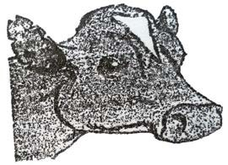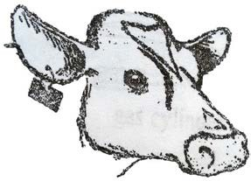

**Animal** identification is basically done by numbering animals.

### Numbering

* This means putting a mark or label on the body of animals.
* Numbering enables farmers to identify animals easily.

### Ways of numbering

1. Branding
2. Ear Notching
3. Ear tagging
4. Number lacing
5. Ear tattooing
6. Tail Bobbing

### Ear notching

* This is the cutting of the edge of the ears of animals with marks.

### Diagram

1. **Ear Tagging**

This means fixing tags with numbers on the ear of animals.

### Diagram

1. **Numbering Lacing**

This is the putting of a wooden o iron piece of plate around the neck of animals.

### Diagram

1. **Ear tattooing**

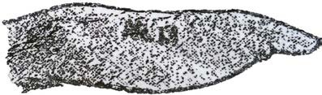

This means putting permanent mark on the ears of animals using pliers carrying numbers on them.

### Diagram

1. **Tail bobbing**

This means trimming long hair on the animals’ switch.

### Learner’s activity.

* 1. Briefly e dandelion explain the following terms

i) Steaming up

i) Drying off

i) Calving

* 1. How is colostrum important to a calf.
  2. Why do you think a cow should be separated from the herd before calving?
  3. List down any **two** signs of a cow on heat

## **CORRECTION**

### OTHER PRACTICES CARRIED OUT ON CATTLE FARMS

**Castration**

* Castration is the removal testicles from male animals. The main aim of castration is to make the bull unable to fertilize a cow.

### Reasons why farmers castrate farm animals

1. To prevent un wanted pregnancies.
2. To make male animals docile for easy handling.
3. To prevent random mating.

### Methods of castration

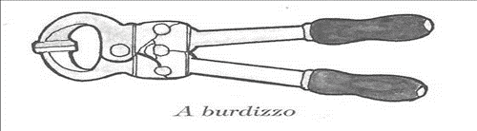

* 1. Open castration method.
  2. Closed castration method
  3. Use of the loop or elastrator method.

### Open castration method

* In open castration method, a sharp instrument is used to cut, open the scrotum then the testicles are removed.

### Closed castration method

In a *closed castration method*, an instrument called a burdizzo is used to crush the tubes leading to the scrotum.

### A drawn structure showing a burdizzo

1. **Use of the loop method**

* In this method, a rubber ring is used to seal the sperm ducts and thus killing the epididymis

### Advantages of castration:

* 1. Castrated bulls grow faster and fatten
  2. Castrated bulls are calm, humble and easy to handle
  3. Castration helps to control venereal inbreeding (unwanted pregnancies in the herds)
  4. Castration also helps to prevent diseases on a farm

### Disadvantages of castration

1. Animals are denied chance to enjoy natural mating.
2. There is loss of blood from the animal
3. The wounds may become septic and attract germs
4. It is painful to animals

### Note:

The use of the ring prevents blood from flowing into the testis that will cause them to shrink and fall off.

In an open castration, the scrotum is cut open using a razorblade or a sharp knife and the testes are removed.

### Learner’s activity.

1. Briefly explain the term castration
2. Give **two** reasons why livestock farmers castrate farm animals
3. Cite out any **two** methods of castrating animals
4. Why do you think bulls which are not castrated usually get STDs?

## **CORRECTION**

### DEWORMING AND DEHORNING.

**Dehorning**:

* Dehorning is the removal of horn buds from the young animals to prevent growth of horns.
* Dehorning should be done when the calf is about 2-3 months.

### Methods of dehorning

1. By use of chemical (done between 3-14 days)
2. By use of a hot iron (between 7-30 days)
3. Use of spoon dehorners. (between 1-2 month)

### Advantages of dehorning

1. It makes the animal easy to handle
2. It increases the space in kraals, milking shades and in vehicles during transporta- tion.
3. Many animals can be kept in a small space
4. It reduces the risk of injury among animals.

### Deworming

* Deworming is the act of giving drugs to animals through the mouth to kill internal parasites

### Deworming is done in two ways:

* *Drenching* is the act of giving liquid medicine to animals through the mouth. It can be by using a drenching gun.
* *Dozing*. Is the act of giving solid medicine to animals in order to kill internal para- sites

### Importance of deworming

Deworming kills internal parasites like tape worms etc.

### Spraying

* This is the removal of ecto parasites on the body of an animal by sprinkling acari- cides using a knap sack sprayer or spray race.

### Deticking

This is the picking of ticks from the skin of animals using hands.

### Dipping

This means making animals to swim through water mixed with acaricides in a dip tank.

### Learner’s activity

1. Give a difference between drenching and dozing
2. State a reason why livestock farmers should deworm their animals
3. State the importance of dehorning from animals

## **CORRECTION**

### MILKING IN CATTLE

**Milking.**

Is the drawing milk from the cow’s udder.

* Milk is got by squeezing the teats of cow
* Milk is secreted from the mammary glands of a female animal.
* Milk contains over 85% water and 15% proteins fats, calcium, phosphorous

### Methods (Types) of milking

1. Hand milking
2. Machine milking

### Note:

*Hand milking*: is the act of squeezing the teats of a cow using hands. This method can be used to 1-3 animals.

*Machine milking* is the act of using a machine to squeeze the teats of cow. Machine milking is the best for more than five animals.

### Note:

A cow can hold up or hide milk if it’s disturbed.

### Disadvantages of machine milking

1. Needs a trained person to operate machine.
2. The machines are expensive to buy.
3. The udder may be injured in case of a machine fault.

### Preparation for milking

1. Assemble the milking equipment.
2. Put the cow in a milking place and tie the hind legs with a rope.
3. Wash the teats, udder and your hands
4. From each teat, draw one or two streams of milk through a strip cup to detect the presence of mastitis in milk.
5. Start milking.
6. After milking, wash the milking place and equipment using disinfectants.

### Note:

A lactometer is used to detect the presence of added water in milk and separates fats from milk.

### NB

1. Before milking, all cows should be tested for mastitis and the cow discovered with mastitis should be milked last.

### Diagram of a strip cup

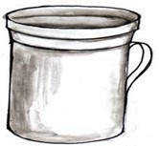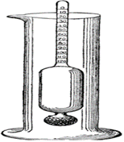

1. The density of milk is measured using a lactometer

### A drawn structure showing a lactometer

**Learner’s activity**

1. Identify the type of milking commonly used in your locality
2. State how the following equipment are useful to a livestock farmer
   1. A Strip cup :
   2. A lactometer :
3. List down **three** ways of obtaining clean milk

## **CORRECTION**

### PRESERVATION OF MILK

**Milk products**

**AND MILK PRODUCTS**

The following are the products got from well processed milk.

### Milk products How it’s made Usage

Cheese Made by sour milk then thickening it by salting

Put in bread or cookies

Skimmed milk Separating fats from milk For frying foods

Yoghurt Turning milk after remov- Used to be mixed into

Ghee Made by boiling butter For frying foods

Milk preservation refers to keeping milk for a long time without going bad.

### Methods of preserving milk are

1. Pasteurization
2. Sterilization
3. Refrigeration

### NB:

*Sterilization* involves killing it on cooling.

bacteria in milk with maximum boiling followed by covering

*Pasteurization* involves strong heating and sealing milk before germs enter. This meth- od was discovered by Louis Pasteur.

### Learner’s activity

* 1. State what you understand by the term milk preservation.
  2. Give **two** ways of preserving milk.
  3. State how yoghurt is made from milk .
  4. Give **two** reasons for preserving milk.
  5. State the importance of the following milk products to people
     1. Cream :
     2. Ghee :
     3. Butter :

## **CORRECTION**

### Practices that harm cattle and other domestic animals in a home, the field, trans- it and abattoir:

**At home:**

⇒ Overcrowding of animals

⇒ Beating animals

⇒ Tying the legs of a cow tightly when milking

⇒ Poor feeding of animals

### In the field

* Beating animals
* Making the rope too tight when tethering animals
* Over stocking

### In transit:

⇒ Beating animals

⇒ Making animals walk very long distances without food or water.

⇒ Tying the legs and neck of animals when transporting them.

### In the abattoir:

* Slaughtering in-calf cows
* Starving animals before slaughtering
* Cruel methods of slaughtering animals

### LESSON 6 : CATTLE PARASITES

**Parasite**

*A parasite* is an organism that depends on another organism for food and shelter.

Cattle parasites are divided into two;

1. External parasites (ecto-parasites)
2. Internal parasites (endo-parasites)

### External parasites (ecto parasites)

These are parasites that live outside the body of a host. They suck blood from the animal.

### Examples include:

*Ticks *Lice *Mites *Tsetse flies Fleas etc.

### Note:

Ticks suck blood from the animals and spread tick borne diseases such as;

* East coast fever
* Red water
* Heart water.
* Anaplasmosis

*Tsetse flies* spread germs that cause Nagana or trypanosomiasis to cattle.

### Internal (endo) parasites

* These are parasites that live inside the body of the hosts and mainly in the intes- tines.
* They suck blood and feed on the digested animal’s food. They are mainly worms.

### Examples include;

* Tape worms feed on digested food
* Liver flukes live in the bile duct or liver.

### Ways of controlling cattle parasites

* Spraying the animals using acaricides
* Practicing paddock grazing to prevent tick borne diseases
* Dipping cattle in a caricides
* De-worming cattle to kill intestinal worms

### Learner’s activity

* + 1. What do you understand by the term parasites?
    2. Name the **two** types of parasites
       1. (ii)
    3. How do parasites gain entry into the animal’s body?
    4. Give **two** examples of external cattle parasites
       1. (ii)
    5. Briefly explain **two** ways of controlling parasites on a farm

## **CORRECTION**

### Signs of a sick animal include;

1. Animals appears gloomy and restless
2. Body temperature may be high or low
3. It may pass out urine with strange colours
4. Difficulty in breathing or even coughing
5. Diarrhea or scouring may occur

### Name of disease How its spread and

**caused**

**Signs and symptoms Prevention**

**control and**

**Bacterial diseases**

Anthrax

Caused by Bacteria Spreads through

body contacts and contaminat- ed feeds

High fever

Loss of appetite to graze.

Sudden death Blood stained dung

Bury deeply dead animals

Burn the dead animals

Vaccinate ani- mals every year

Separate infect-

Mastitis Caused by bacteria

Spreads through body contact with an infected animal

Milk with blood stains or pus

Swollen and painful teats and udder.

A cow refuses to be milked and suckled

Early treatment by treating us- ing antibiotics

Use a strip cup regularly

**Viral diseases** Foot and mouth disease

Spreads through sharing feeding containers

Through body con- tacts with infect- ed animals

Swollen teats and lameness

Blisters on top of hooves and mouth (muzzle)

Loss of appetite to graze

High temperature

Reduction in milk production

Separate sick animals

Vaccinate after every 6months

Application of a quarantine.

Rinderpest Spread through

body contact with an infected animal

Soars in the mouth

Sunken eyes Nasal discharge Tears from eyes High temperature

Diarrhea with blood stains

Separate sick

animals

Regular vac- cination

Slaughter the infected ones

**Protozoan disease** Nagana (trypanosomiasis

)

Spreads through the bites of in- fected tsetse flies

Loss of weight Anemia

Loss of appetite

High fever

Spread the tsetse flies using insecticides

East coast fever Through bites of in-

fected ticks (brown ear tick)

Nasal discharge Diarrhea

Loss of appetite High temperature

Dipping and spraying animals with aca- ricides to con-

trol ticks

Heart water Through bites of in- fected ticks

(brown ear tick)

Animals walk in circles.

Animals place their heads on objects

When the animal falls, legs keep paddling in air

Dipping and spraying animals with aca- ricides to control ticks

Treat early cases with tetracy- cline antibiotics and sulphadi-

Red water Spread through tick bites (red ticks)

High fever

Reddish urine due to damaged liv- er.

Animal licks soil

Vaccinate regularly.

Dip and spray with the acari- cides to kill

### Learner’s activity

1. Give examples of viral and bacterial diseases of cattle
2. Point out any **one** cause of sickness in cattle
3. Identify the infection of cattle that attacks
   1. Udder :
   2. Respiratory system of the animal :
4. Give **two** ways of controlling cattle diseases

## **CORRECTION**

### STARTING A LIVESTOCK FARM

*Livestock* refers to the animals kept on a farm. These may include; Poultry Goats Sheep Pigs and Cattle

Livestock farming is the rearing of farm animals.

### It’s important to people in the following ways;

1. It’s a source of income when animals and their products are sold
2. It’s a source of food
3. It provides employment opportunities to people

### Requirements for starting a livestock farm.

**For one to start alive stock farm the following requirements should be in place.**

* 1. Land
  2. Capital
  3. Labour
  4. Market
     1. ***Land*** this is a place on which the farm is started. It may be obtained in the following ways;
* By buying
* Through inheritance
* From donation
  + 1. ***Capital,*** this is the money used to buy things needed to start a farm. Some of the things the money may be used for include;
* Buying land if it is to be bought
* Constructing animal houses, stores, office and stationery.
* Preparation of pasture
* Bringing water on the farm
* Paying workers and experts for the treatment an vaccination of the farm animals before the farm starts producing.
* Buying drugs, acaricides and necessary equipment for the farm.
  + 1. ***Labour,*** this includes people who do activities on a farm both skilled and unskilled workers.
* *Market,* in livestock farming, marketing refers to the demand for cattle or their prod- ucts.
* Demand for cattle products means the desire and ability to pay for the products. Therefore, it’s important to know whether people are ready to buy the products from the farm.

### Farm records:

These are written information about all activities carried out on farm.

### Importance of keeping farm records

1. Helps the farmer to plan and budget for the farm.
2. To help the farmer know whether he is making profits or losses.
3. To enable the farmer to make decisions

### Types of farm records

* **Feeding records:** These show the amount of feeds bought, consumed and methods of feeding.
* **Breeding records**: These include reproduction, birth or death rates.
* **Production records:** These show yields of various farm produce e.g. eggs, milk, meat etc.
* **Health records:** These include when and which animals were sick, what treatment they got or which ones to cull.
* **Labour records:** These include the number of farm labourers, type of work they do and their wages.
* **Marketing records:** These include where, when and what prices various products were sold.
* **Income and expenditures**: These are records of all the sales and purchases of the farm business.

### Learner’s activity

* 1. Give a difference between livestock and livestock farming
  2. Today in Uganda, many people prefer livestock farming to crop growing. Give **two**

reasons for this.

* 1. Identify any **two** ways of obtaining land for starting a livestock farm.
  2. List any **two** activities done by skilled and non-skilled worker on a farm.
  3. Give **two** ways in which capital can be used in starting a livestock farm
  4. Why should a cattle keeper have records on his farm?

## **CORRECTION**

**CORRECTION**

**CORRECTION**

### TOPIC 3 : RESPIRATORY SYSTEM ORGANS OF THE RESPIRATORY SYSTEM

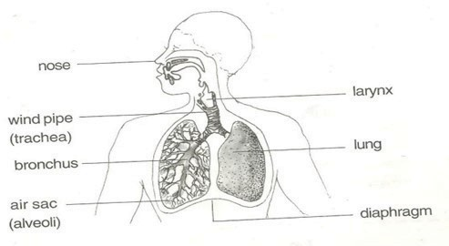

**Main product**

* Energy
* By product – water, carbon dioxide

### Raw materials for respiration

* Food
* Oxygen

### A drawn structure showing the respiratory system

**Functions of the parts**

#### The nose:

It contains cilia that fitters inhaled air

It contains mucus that helps to moisten and warm inhaled air

### The wind pipe/trachea

It is a passage and air to and from the lungs

### NB

The trachea is kept open all the time by cartilage rings.

#### The epiglottis:

Closes to prevent the food from entering into the wind pipe on swallowing.

#### The lungs:

* This is the organ where gaseous exchange takes place.
* It has got air alveoli that help in gaseous exchange
* The ribcage also presses the lungs during exhalation in order to let out air

#### Rib cage:

* Protect the lungs and heart against external harm.
* It’s also covered with a pleural fluid to prevent friction between the thorax and lungs to the ribs.

### Note:

Gaseous exchange takes place at the air sacs.

### Learner’s activity

1. State the importance of respiration to the body
2. Give a reason why it’s not advisable to breathe through the mouth
3. How are cilia useful to people during breathing?

State the importance of the following organs of the respiratory system;

(i) Nose :

Rib cage :

Epiglottis :

1. How do plants benefit from the process of respiration?

## **CORRECTION**

### BREATHING

Breathing is the taking in and out of air.

### Process of breathing

⇒ Breathing in (Inspiration / inhalation)

⇒ Breathing out (Expiration / exhalation)

### Breathing in / inspiration / inhalation.

* *Inspiration* is the taking in of air by an organism.
* We breathe in to get oxygen for respiration in the body.

### Events during inhalation / breathing in.

⇒ Diaphragm contracts and flattens.

⇒ Ribs move upwards and out wards.

⇒ Lungs expand

⇒ The chest increases in volume

### Expiration / breathing out / exhalation

* This is the taking out of air from the body of an organism
* We breathe out to reduce carbon dioxide in the body.

### Events during expiration / breathing out / exhalation

⇒ The diaphragm contracts and moves to its dome shape.

⇒ The ribs move down wards and inwards

⇒ The lungs reduce in size

### Note:

Carbon dioxide dissolved in the blood plasma diffuses from the capillaries into the alve- oli and exhaled out.

Abrupt coughing is caused when an external matter enters the trachea or wind pipe

### Learner’s activity

1. Differentiate between breathing and respiration
2. State what happens to the following parts during breathing in
   1. Diaphragm :
   2. Lungs :
   3. Intercostal muscles :
3. By what process does oxygen enter into blood?

## **CORRECTION**

### ADAPTATION OF THE ALVEOLI TO THEIR WORK

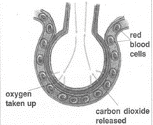

**Gaseous exchange in the alveolus**

**An illustration showing gaseous exchange in the alveolus**

**How are air sacs suitable for gaseous exchange?**

1. They have thin walls that allow easy diffusion of gases
2. They are surrounded by a network of blood capillaries.
3. They are many in number to increase a surface area for gaseous exchange

### Summary of the composition of inhaled and exhaled air

**Gas Inhaled air Exhaled air**

Oxygen 21% 16%

Carbon dioxide 0.03% 4%

Nitrogen 78% 78%

Water vapour Less More

Rare gases 0.97% o.97%

### Note:

* + As we breathe out, more carbon dioxide is expelled because some carbon dioxide is produced by body cells during respiration
  + Nitrogen is left unchanged because it is not necessary in the body.
  + We breathe out less oxygen because most of it is used by the body during respira- tion

### Learner’s activity.

* 1. State **two** ways in which alveoli are adapted for exchange of gases.
  2. Study the table below and answer the questions that follows;

|  |  |  |
| --- | --- | --- |
| Component | Inhaled air | Exhaled air |
| Oxygen | 21% | 16% |
| Nitrogen | 78% | 78% |
| Carbon dioxide | 0.03% | 4% |

1. Briefly explain why;
   1. Exhaled air contains little oxygen
   2. Concentration of nitrogen remained unchanged
   3. Exhaled air contains more carbon dioxide

## **CORRECTION**

### DISEASES OF THE RESPIRATORY SYSTEM.

*Respiratory* diseases are diseases that affect people’s respiratory organs i.e. the lungs, trachea, nostrils, and bronchioles.

* + Some respiratory diseases are communicable diseases spread through contaminated air while others are non-communicable caused by smoking.
  + Some respiratory diseases are hereditary spread from parents to the babies.

#### Diseases of the respiratory system.

**Diseases Signs and symptoms Prevention / control**

Lung cancer (caused by smok- ing)

Influenza (flu) (caused by virus)

Pneumonia caused by either bacteria or virus

Chest pain High fever

Difficulty in breathing Constant coughing and sneez-

ing

Difficulty in breathing Coughing

Avoid smoking tobacco Seek medical treatment

Drink a lot of fluids

Wear warm clothes during cold weather.

Treat using antibiotics.

Bronchitis (caused by bacte-

Difficulty in breathing Treat with antibiotics

Tuberculosis. (caused by bacte- ria)

Whooping cough

(caused by bacte- ria)

Loss of weight Mild fever weight Night sweats Chest pain Blocked nose

Coughing spasm Difficulty in breathing Runny nose

Isolate the infected ones

Immunise using children BCGVaccine

Avoid drinking unboiled

Drink fluids rich in vitamins Immunise children with

DPT vaccine.

Avoid overcrowded and poorly ventilated hous- es/places.

Asthma (allergies) Difficulty in breathing

Body weakness during cold weather.

Mucus flow

Go for medical attention

Keep away from sources of allergies e.g. cold pollen grains.

Diphtheria (caused by bacte- ria)

Sore throat Convulsion swollen neck

Immunise the infants us- ing DPT vaccine

Go for medical treatment

### Disorders of the respiratory system

* Choking
* Hiccups
* Sneezing etc

### Habits that improve the working of the respiratory system

* Avoid smoking
* By having regular physical exercises.
* Feeding on a balanced diet.
* Keep away from dusty places etc.
* Stay in well ventilated houses/places

### Learner’s activity.

1. Identify any **two** diseases of the respiratory tract
   1. (ii)
2. Describe any **two** ways of keeping the respiratory system in a healthy working condition.
3. Draw the structure of the respiratory system and name the parts;
4. Trachea
5. Left bronchus
6. Diaphragm
7. Lung
8. Write SARS in full

# CORRECTION

### Uses of fossils

* Fossils help geologists to determine the age of a place or rock.
* Fossils help geologists to know how different plants and animals have existed and changed.
* Fossils help to tell how land looked before.
* Fossils show us how and where the different sedimentary rocks were formed.
* Fossils help to tell what the animal or plant looked like, what it ate, where it lived etc.

### Learner’s activity

1. Write any **one** way in which each of the following can be used as a resource;
   1. Water :
   2. Sun :

(c ) Soil :

(d) Air :

1. How can rocks be useful to people? (Give **one** way)
2. Briefly explain the term fossils

**CORRECTION**

**Water :** Water is a renewable resource when used carefully.

### How water is used as a resource?

* Water is used for cooking, washing etc
* Water is used as a coolant in fractions
* Running water is sued to generate hydro electricity

**Sun :** The sun as a resource

### How the sun is used as a resource

* We get light from the sun that enable us to see
* Our skins make vitamin D using light from the sun
* Heat from the sun is used to sundry harvested crop produce
* Plants are a source of building materials e.g. poles, timber

### How are plants used as resources?

⇒ Some plants are a source of food to people.

⇒ Some plants give us natural plant fibres like cotton, sisal, jute and linen.

⇒ Some plants are a source of herbal medicine to cure certain diseases.

### How are animals used as resources?

* Some animals like merino sheep provide wool, used to make cloths, suits, blankets, carpets, curtains, bed sheets etc.
* Silk worms provide silk used to make different types of cloths.
* Some domestic animals provide skins and hides used to make bags, shoes, belts, etc
* Cattle provide horns and hooves used to make glue.
* Bees help to pollinate farmers’ crops, provide honey and bee wax.
* Some animals like oxen and donkeys provide labour.

### Air and Wind

* Both are renewable resources
* Air is a mixture of gases
* Wind is moving air.

### How wind is useful

* Wind turns wind mills to produce electricity
* Wind drives wind mills to draw water from the underground and millgains
* Wind helps in winnowing

### ALLOYS

An alloy is a mixture of two or more metals

|  |  |  |
| --- | --- | --- |
| Alloy | Combination | Uses |
| Brass | Copper and Zinc | Decorating orna- ments  Making wires, tub- ing cases for  bullets. |
| Dentist Amalgam | Gold and Copper, gold, | Making coins. |
| Solder | Lead and Tin | Joining metals |

### Why are alloys made?

* To make the metal harder
* To lower the melting point of the metal.
* To make the metal more resistant to corrosion i.e. wear and tear
* To increase the electrical resistivity of metals.

### Learner’s activity

1. Briefly explain the term alloy
2. Give **two** examples of alloys
   1. (ii)
3. State then importance of the following alloys;
   1. Brass :
   2. Manganese steel :
   3. Cupronickel :
4. Point out any **two** uses of alloys in our society

## **CORRECTION**

### Living things as resources Plants as resources

* Some animals are eaten as food
* Plants provide wood used for building houses and making furniture.
* Some plants are sources of herbal medicine.
* Some plants are sources of fibre.

### Animals as resources:

* Some plants are eaten as food.
* Some animals are used for transport.
* Some animals provide hides and skins used to make leather products.
* Their hooves are used to make glue and buttons.

### Types of resources

1. Renewable resources
2. Non- renewable resources

#### Renewable resources:

*Renewable resources* are resources that can be naturally replaced.

### Renewable resources include;

(i) Water (ii) Plant (iii) Animals (iv) Air (v) Soil

### Characteristics of renewable resources

They can naturally be replaced

### Importance of plants as resources.

* They can get exhausted
* They take millions of years to be formed
* They exist in limited quantities
* Rocks
* Minerals
* Fossil fuels (Petroleum, coal and natural gas)

#### Non-renewable resources.

*Non-renewable resources* are resources that cannot be replaced naturally when used up.

### Characteristics of non renewable resources:

* These resources cannot be replaced when they get used up.
* These resources can be exhausted in case they are not properly handled and pre- served.

### Examples include;

1. Rocks (iii) Clay (v) Sand
2. Petroleum (iv) Minerals

### Resources from nonliving things

A nonliving thing is one without life.

1. Soil (iii) Air and wind
2. Water (iv) Rocks and minerals

### Learner’s activity

1. Differentiate between renewable and nonrenewable resources
2. Give **two** examples of renewable resources in your environment
   1. (ii)
3. Write **one** sentence to explain why copper is regarded as a nonrenewable resource.
4. Stat **one** way in which the following can be used as a resource.
   1. Water :
   2. Soil :

## **CORRECTION**

### Conserving renewable resources Conserving renewable resources

* Wild life refers to animals and plants in our environment.
* Many kinds of animals have disappeared from earth and they are extinct.
* Other animals are about to disappear and we say they are endangered.
* Animals may become endangered or extinct because they are killed for their skins, horns, tusks.
* Some plants have also become endangered or extinct due to the increasing demand for wood and local medicine.

### Conserving non renewable resources

* Soil erosion should be controlled.
* Soil should be kept fertile by using manure and fertilizers.
* Plastic wastes like broken Jerrycans, polythene papers should be recycled.
* Vehicles in dangerous mechanical conditions should be repaired to conserve fuel.
* Petroleum products should be used wisely to prevent further exploitation of oil

### Learner’s activity

1. What do you understand by the term conservation of resources?
2. Give **two** ways of conserving the following resources in our environment
   1. Wild life
   2. Soil


      3. Minerals
3. Briefly explain the term fibre
4. Give **two** examples of plant fibres
   1. (ii)

## **CORRECTION**

**CORRECTION**